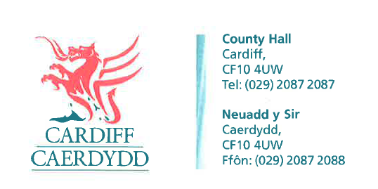
FOI Response Document
FOI18205

Thank you for your request under the Freedom of Information Act 2000 about Commissioning Framework received on 01/08/2022.

Request
The purpose of this request is to develop an understanding of what is good practice in joint commissioning and funding of external placements with health/CCG/ICBs and children's social care.
- Do you have a joint commissioning framework for externally commissioned placements for children?
  - If yes, does this joint commissioning framework include partners from 'health' (eg, CCG or new ICBs)?
  - Please share the terms of reference (ToR) or joint agreement, if health are included
Response: The City of Cardiff Council does not hold this information therefore under Section 17 of the Freedom of Information Act 2000 this acts as a refusal notice.

Under Section 16 of the Freedom of Information Act 2000 we have a duty to advise and assist our customers. Cardiff Council can confirm that while it is a part of an All-Wales Framework agreement delivered by the 4C’s and hosted by RCT (Rhondda Cynon Taf) Local Authority, the requested information in relation to the framework would need to be obtained from the RCT 4C’s team directly.

- Do 'health' eg CCG/ICB, joint fund externally commissioned placements (eg, residential, therapeutic foster care, SEND, semi-independent provision)?
  - If yes, what are the terms (please share a ToR or agreement)?
  - If yes, how is that funding split for the following: (e.g. a shared percentage cost)
    - Residential
    - therapeutic foster care
    - SEND provision
    - semi-independent provision
Response: Cardiff Council can confirm that while Health do jointly fund some placements there is no overarching agreement in place and this is completed on a case-by-case basis. The pathway for completing this is through the Statutory Brighter Futures Panel for all external placements.

Internal placements are discussed on a case-by-case basis as health costs/requirements are identified. The Health Board have a funding panel where the cases are presented by Health and decisions returned to the Local Authority.

- Do any other partners contribute (over and above children's social care and health/CCG)?
  - If yes, who and on what terms?
Response: Cardiff Council can confirm that the education team contributes to placements which include education which meets the requirements. These costs are usually associated with placements which are out of area and therefore the pathway is the Statutory Brighter Futures panel.

- Is the criteria in the 'continuing care funding' model used as a methodology for split funding?
  - If yes, is this the only criteria 'health' use to determine funding?
Response: Cardiff Council can confirm that continuing care is additional to care which is provided either as a universal service, or a specialised service. It is not an alternative. It is needed because universal or specialised services do not fully meet a child or young person’s needs, due to their complexity.
An assessment of needs should be undertaken on the basis that it is believed that these existing services are insufficient to meet a child or young persons’ needs. An assessment for continuing care and agreement of eligibility should not be undertaken to remove an effective existing package of support or shift commissioning responsibility between health and social care.
If a child or young person is found to be eligible for children and young people’s continuing care (CYP CC) agencies such as health, education and social care must work together to ensure that there are no gaps in meeting those assessed needs. A LHB (Local Health Board) and a LA (Local Authority) may therefore jointly fund care to meet a child or young person’s needs as part of a joint health and social care package.

- What was your Council 2021/22 yearly spend on external placements?
Response: Cardiff Council can confirm that the spend for external residential & fostering, for 2021/2022 was £34,616,706.
  - What element of that was funded by health?
Response: Cardiff Council can confirm that 1.85% was funded by health
  - What element of that was funded by education?
Response: Cardiff Council can confirm that 1.34% was funded by education
  - What element of that was funded by 'other'?
Response: Cardiff Council can confirm that 1.56% was funded by ‘other’
- Have you involved children or parents in your joint commissioning process?
Response: Please see the response to Q1, this information would be held by the RCT 4C’s team.
- Do you refer to any models of practice in your commissioning framework or joint funding framework?
  - If yes, please share this?
Response: Please see the response to Q1, this information would be held by the RCT 4C’s team.
- Do you have any other comments?
Response: N/A

If you have any queries or concerns, please do not hesitate to contact us.
Please remember to quote the reference number above in any future communications.

